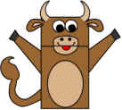
Paper Bag Cow, Owl & Mice puppets:

Materials needed:

Brown paper bag

Crayons

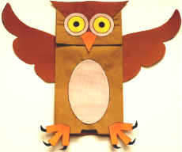
Scissors

Glue

Printer & printer paper

Templates – print off as required

Wiggly eyes (optional)

How to make:

The paper bag should be closed and flat like a piece of paper. On one side it is smooth, this will be the back of your puppet.

It is important that the girls get the back and front sorted at the beginning.

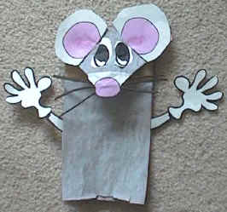
On the other side there’s a flippy tab (which is typically the bottom of the bag when you are carrying your lunch around), this flippy tab will be the head.

Lift the flippy tab up a bit. Underneath of the tab will be the mouth. When the girls put their hand in the bag, they will be able to make the puppet talk.

Looking at the rest of the front of the bag, this will be the body. On the sides there should be a flap of paper, this is where the arms will fit.

Attach all pieces as per the pictures.

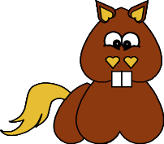
Horse stick puppet:

Materials:

Paper

Glue

Scissors

Print template onto card

Directions:

Colour where appropriate

Cut out template pieces and glue pieces together.

Attach a stick to the back to make it into a stick puppet.

